PCT PROCESS

PCTs are created in Canopy. Select Canopy is SSO menu.
Step 1-3: Go to Payroll > Payroll Cost Transfer > PCT Worksheet

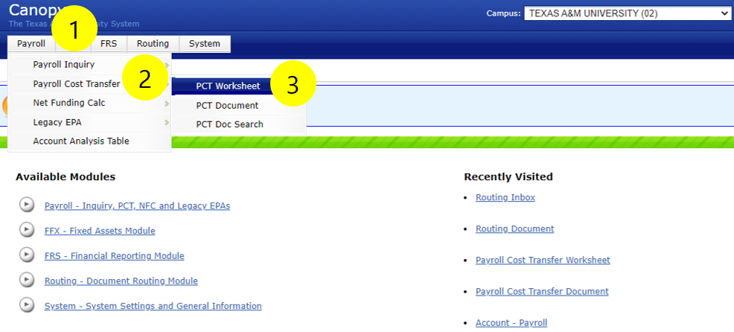

Step 4: Enter UIN. If UIN is not found, enter employee name. Enter as Last Name, First Name. If the employee is inactive, check the box titled “Show Inactive”
Step 5: Pick Fiscal Year.
Step 6: Pick pay period to be corrected. If you are transferring multiple payroll periods, a PCT will need to be created for each payroll.
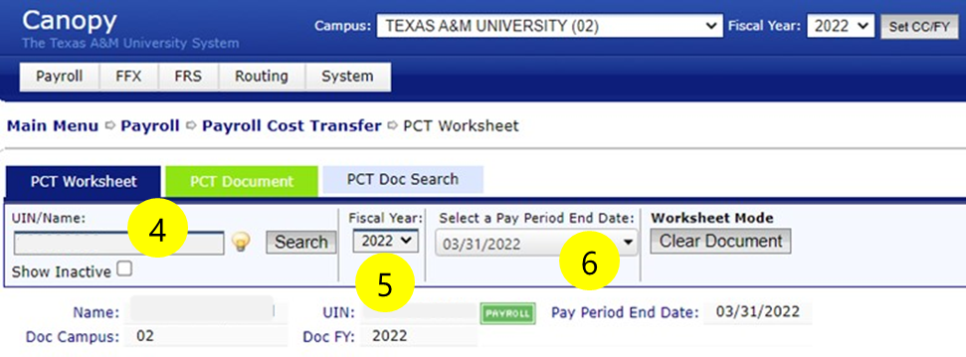

Step 7: Change campus code, SL and SA of line to the new account for the salary. You may enter Percentage or Salary/Wage, but not both. The PCT process will reduce the account in the solid white upper portion by the amount you enter in the shaded portion on the lower side of the screen. If the entry has benefits only, you may input the total benefits amount in the New Salary Amount box.
Step 8: Click Save. (Example of transferring a portion of a salary, or multiple lines is shown below in Figure A).
Step 9: Click on Go to Document. This takes you to the PCT Document screen.

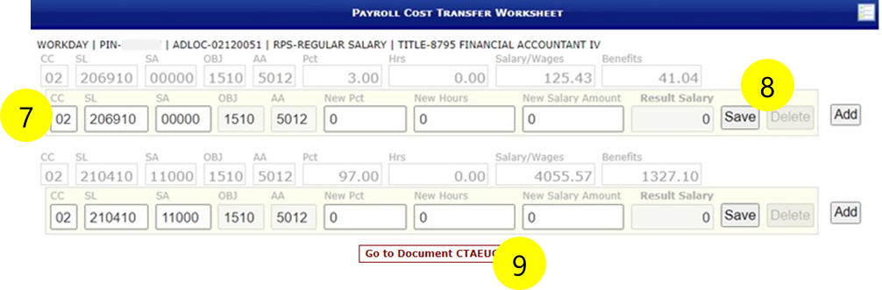

-Figure A-
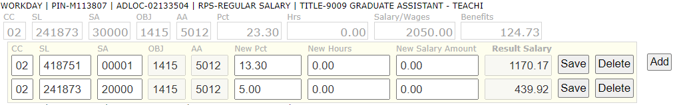
In this example, 18.30% was taken out of 02-241873-30000 and split up in to two different support accounts. You are not required to type in the remaining 5% of the original SA in the PCT you create.

Step 10: Enter Description of your choice.
Step 11: Select Justification code. If “Other” is chosen, you must add a note at the bottom of the document.
Step 12: Attach documents as needed to justify the PCT.
Step 13: In Action Box up top, select “Close and Route”

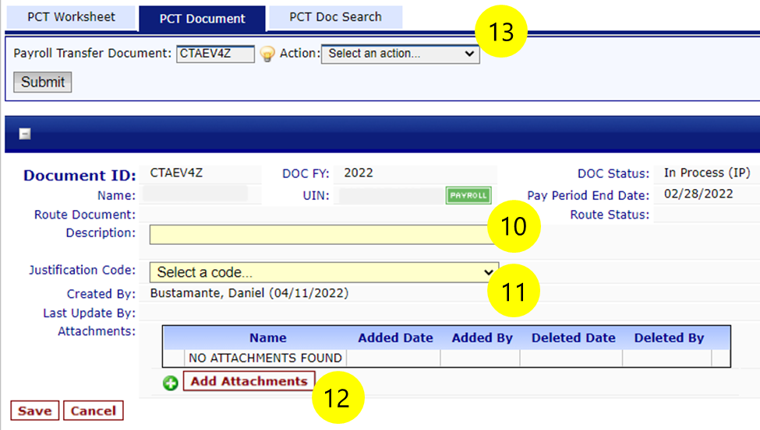

- If account is over budget, you will get an error and will need to correct the deficit or lift budget flag to process PCT.
- An encumbrance will be created for the new account on the PCT. Once PCT has received all approvals and is marked Complete, the encumbrance will be removed.

- You may view the progress of the PCT by choosing Routing/Document. Enter document as ECTXXCTXXXXX, with first two X as System part.

