Howdy,

Texas A&M University is a registered employer with other states and their local taxing jurisdictions. Most states and their local jurisdictions have unique tax laws with which Texas A&M University must comply. To that measure, Texas A&M University withholds from employees, including student workers, all applicable state and local income taxes. These taxes are withheld from those who maintain their residency within a state or locality that levies an income tax, even if they perform services outside of that state. These taxes are also withheld from those who physically work within in a state that levies an income tax, even if claiming residency in another state. In summary, all employees who claim residency or physically work in a state that levies an income tax will have state and/or local income taxes withheld from their wages as required by law.

For State/Local Income Tax reporting purposes please:
- Verify, in Workday, your Home Primary Address and your Alternate Work Location Address are set as your residence and physical work location respectively.
- Enter your State and Local (if needed) tax elections. Any additional forms that are applicable to your state will be provided in Workday as part of your tax election entry.

This packet contains the following documents:
1. Instructions to help you complete the Employee State Income Tax Verification form.

2. Employee State Income Tax Verification Form
To be completed upon request, by employees who work and/or reside in a state other than Texas.

3. Military Spousal Relief Act Election Form
Complete if applicable to you.

4. Pennsylvania Residency Certification Form (Attached for review only, you will complete in Workday)
ONLY residents of Pennsylvania are required to complete this form.

5. Additional TAMU Texarkana Employee Forms (Attached for review only, you will complete in Workday)
ONLY TAMU Texarkana Employees are required to complete these forms.
(Complete the one applicable to you)
Texarkana Withholding Exemption Rules
AR4EC – State of Arkansas Employee’s Withholding Exemption Certificate
AR4EC(TX) – State of Arkansas Texarkana Employee’s Withholding Exemption Certificate
AR4ECSP – State of Arkansas Employee’s Special Withholding Exemption Certificate

Please complete and return all forms to tax@tamu.edu.

Best Regards,
Tax Compliance and Reporting,
Texas A&M University

Instructions for completing the Employee State Income Tax Verification Form

Employee Name: Enter your first and last name

Employee UIN: Enter your University Identification Number

Campus Location: Select the campus where you are employed

Physical Work Location: Enter the city and state of the place where you physically work for TAMU or any of the TAMU System Parts

Date began at physical work location: If you work in a state other than Texas, list the date you began working at that location

Residency Certification: Select one of the residency certifications and complete as instructed:
- First option (Texas resident): Check the box and enter the date your Texas residency began, sign, date and submit.
- Second option (Out-of-State resident): Check the box and complete the remainder of the form.
- Third option (Texas resident): Check the box if you changed your resident address in Workday because you will be moving to the state in question and will not be working for TAMU or any of its System parts from that state.

Withholding Basis: Please log into Workday and enter your State/Local tax election to provide a basis for deducting state/local income tax if you work and/or reside in a state other than Texas.

State Income Tax Election Instructions: https://uas.tamu.edu/tax/instructions.html
Local Tax Election Instructions: https://uas.tamu.edu/tax/instructions.html

Military Verification: Select ‘Yes or No’ to verify your military affiliation. Then complete and sign page 2 if you selected ‘Yes’ for question #2.

Proof of your eligibility for exemption under the MRRA will be needed. As proof of claim, Texas A&M University is required to obtain, a clear photocopy of your current military spouse ID, Form DD 2058 reflecting the servicemember’s state of legal residence, and a recent Leave and Earnings Statement.

Please make sure we have your correct addresses in Workday:
Home: Primary Home Address = your residence address
Additional Home Address = your mailing address
Work: Primary Work Address = set address or notice and can’t be changed
Alternate Work Address = your physically work location (If out-of-state, list the out-of-state address)

IF THERE ARE CHANGES in your residence city/state or your physical work location, you must update your address and state/local tax elections in Workday Immediately.

It is YOUR RESPONSIBILITY to update your addresses and state/local tax elections in Workday.

Employee State Income Tax (SIT) Verification
This form is used for State Income Tax reporting purposes by Tax Compliance & Reporting to verify the physical work location and residence of employees whose payroll records show an out of state residence address. This form is to be completed by the employee. Please complete this form and return to Tax Compliance & Reporting, as noted at the bottom of the form by email, fax or mail. Instructions for this form can be found at https://uas.tamu.edu/tax/_media/state-income-tax-verification-packet.pdf

Employee Name | Employee UIN
Please select your campus location:

TAMU System ___ TAMU College Station ___ TAMU Galveston___ TAMU Corpus Christi___ TDEM___
TAMU Cent TX___ TAMU Texarkana___ TAMU Tarleton___ TAMU West Texas___ TAMU HSC___
Physical Work Location  Where you physically work for TAMU, or any of the TAMU System Parts? (City and State) | Date you began at Physical Work Location  If you physically work in a state other than Texas, please list the date you began working in that state for TAMU or any of the TAMU System Parts.
City:_____________________________________ State:__________________ | MM________ DD________ YY_______
Residency Certification
The payroll records show you claim residency in a state other than Texas , is that correct?
No, I certify that I am a bona fide resident of the State of Texas and not subject to state income tax withholding of any other state. (If this option is chosen, enter the date your Texas residency began, sign, date and return to tax@tamu.edu. Also, please update your Primary home and work addresses in Workday) Date Texas residency began: MM________ DD________ YY________
Yes, I certify that I am a resident of the state indicated below and subject to the state income tax withholding of that state. (If this option is chosen, complete the next two lines, sign, date and return to tax@tamu.edu.)
City and State you claim residency in: City:_____________________________________ State:__________________
Employee Mailing Address (City and State only): City:____________________________________ State:__________________
No, an out-of-state residence is listed for me because I am/will be moving to that residence due to my TAMU employment ending on ____________ or going on LWOP effective ____________ (Enter the dates associated with each option).
By selecting this option, I am certifying that I will not be working for TAMU while residing out-of-state.
(If this option is chosen, you may skip the remainder of this form, sign, date and return to tax@tamu.edu.)

WITHHOLDING BASIS
Please log into Workday and update your State/Local tax election to provide a basis for deducting state/local income tax if you work and/or reside in a state other than Texas and it is determined you are subject to that state’s income tax.

State Income Tax Election Instructions: https://uas.tamu.edu/tax/instructions.html
Local Tax Election Instructions: https://uas.tamu.edu/tax/instructions.html

MILITARY VERIFICATION
YES NO
Are you currently serving in the Armed Forces?
Are you the spouse of someone serving in the Armed Forces?
If you are a military spouse, please complete page 2.
If you are not a military spouse, please disregard page 2.

** IF THERE ARE CHANGES in your residence city/state or your physical work location, you must update your address and state/local tax elections in Workday Immediately. It is YOUR RESPONSIBILITY to update your addresses and state/local tax elections in Workday.

__________________________________________________ __________________________________________________ ____________________
^{Employee Name—Print} ^{Employee Signature} ^{Date}
Complete only if you are a Military Spouse

Military Spouse Residency Relief Act (MSRRA)
A military spouse is exempt from income taxes in a state where income was earned when all four qualifications are met:
The spouse currently resides in a state different than the state of his or her domicile;
The spouse resides in the state solely to live with the service member;
The service member is present in the state in compliance with military orders; and
The spouse and service member are both able to claim the same domicile.

Please click the below link for more information on the Military Spouse Residency Relief Act
https://www.militaryonesource.mil/financial-legal/legal/family-legal-issues/military-spouses-residency-relief-act
If you are a military spouse, please select the correct box to answer the following questions:
Yes No
1. Do you reside in a state different than the state of your domicile?

2. Do you reside in the state solely to live with the service member?

3. Is the service member in the state due to military orders?

4. Are you and the service member able to claim the same domicile?

As proof of claim, Texas A&M University is required to obtain, a clear photocopy of your current military spouse ID, Form DD 2058 reflecting the servicemember’s state of legal residence, and a recent Leave and Earnings Statement.

__________________________________________________ __________________________________________________ ____________________
^{Employee Name—Print} ^{Employee Signature} ^{Date}

SUBMIT FORM(S) TO:  Texas A&M University  Tax Compliance & Reporting | SUBMIT VIA:  Email: tax@tamu.edu  Fax: (979) 458-3131  Mail: 6003 TAMU  College Station, Texas 77843-6003 | QUESTIONS:  tax@tamu.edu  Website: https://uas.tamu.edu/tax/index.html

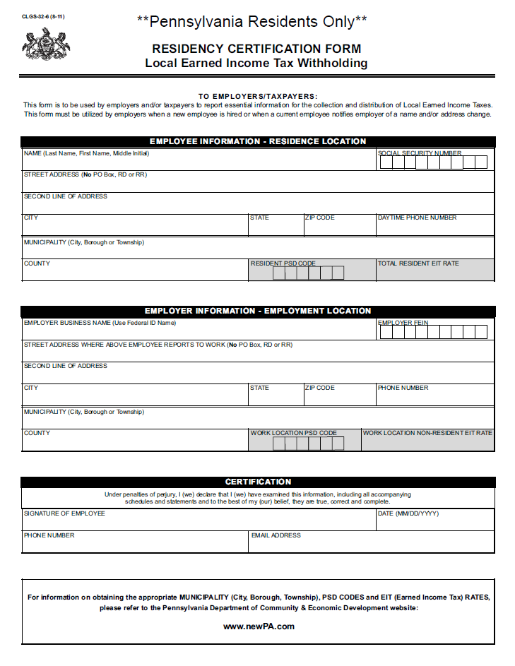
Example – Complete this form in Workday
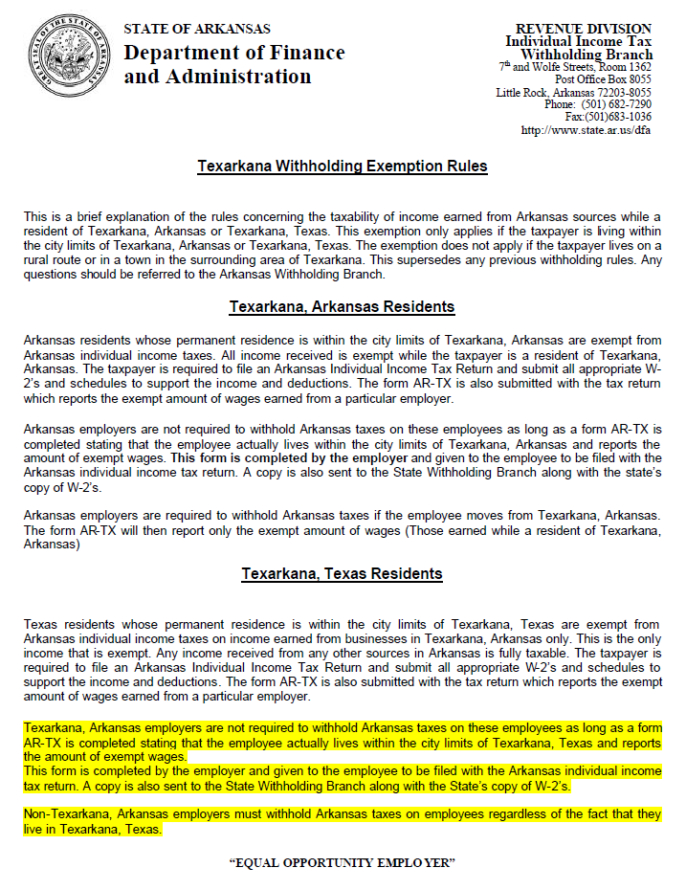
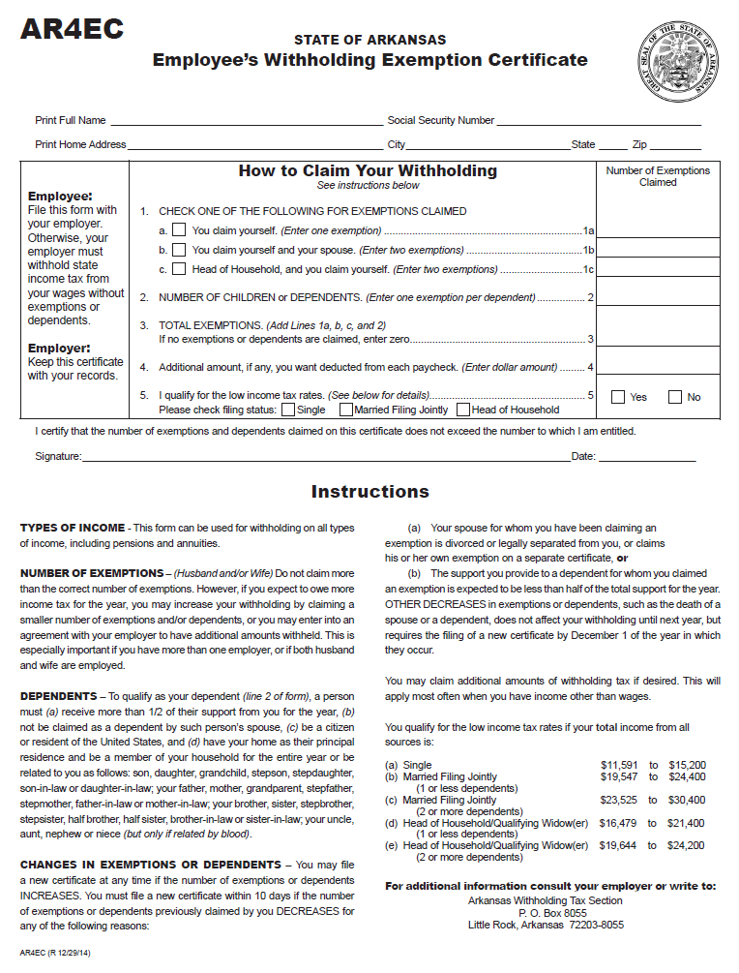
Example – Complete this form in Workday
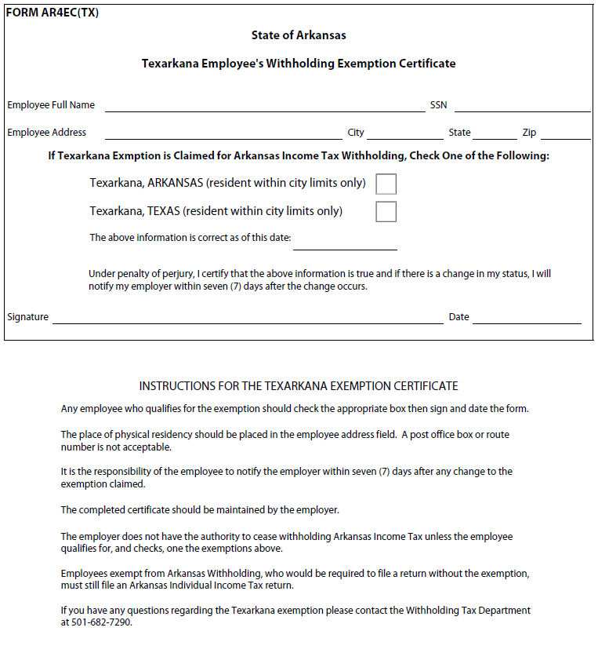
Example – Complete this form in Workday

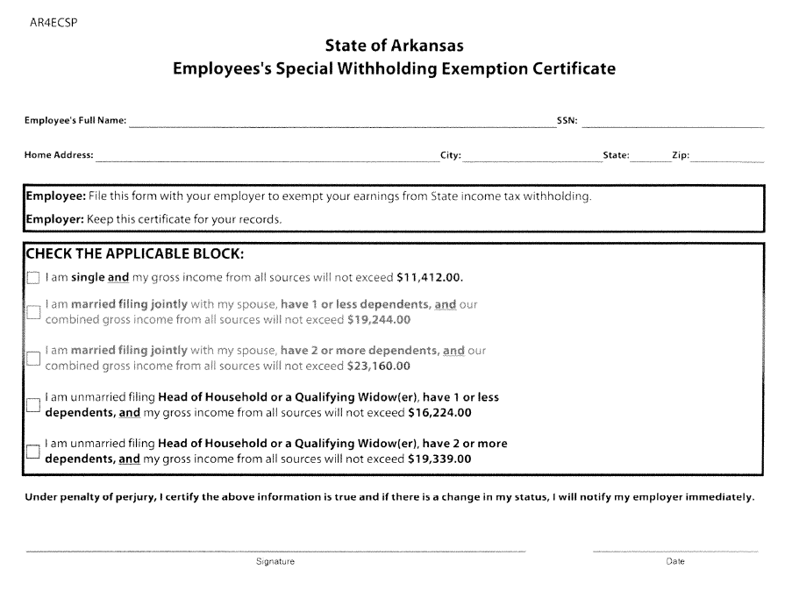
Example – Complete this form in Workday

